Press Release – For Immediate Release
April 17, 2023

Gougeon Brothers, Inc. named one of Michigan‘s 50 Companies to Watch

BAY CITY, Mich. - Gougeon Brothers, Inc. (GBI) is a 2023 recipient of the Michigan 50 Companies to Watch Award by the Michigan Celebrates Small Business (MCSB).

The qualifications for eligibility are rigorous. For selection consideration as one of the Michigan 50 Companies to Watch, the enterprise must meet the following for the year ending 2022.
- Be a privately held, commercial enterprise that has not received the Award in the past (not a nonprofit, publicly traded, or a subsidiary or division of another company).
- Be past the startup stage and facing issues of growth, not survival.
- Employ 6-99 full-time equivalent W-2 employees (including the owner).
- Have between $750,000 and $50M in annual revenue or working capital from either investments or grants.
- Be headquartered in Michigan.
- Demonstrate the intent and capacity to grow based on: employee or sales growth and sustainable competitive advantage.
- Other notable successes.

Receiving this Award is no small feat. GBI's employee-owners are honored for the recognitions received from their work-family and hometown community, but now also, industry outsiders are cognizant on a state-wide scale. GBI's history, product knowledge, and dedicated employee-owners have kept the company ahead of the competition and enabled its epoxy industry success.

"Since day one, we have strived for excellence in all aspects of our business, from product development, manufacturing, and marketing to customer service and support. The acknowledgment is much appreciated; we're all proud of our achievements. We'll remain focused as we forge ahead on this journey towards tremendous success." – Alan Gurski, President & CEO of Gougeon Brothers, Inc.

GBI will be honored at the Michigan Celebrates Small Business Awards Gala on May 2, 2023, at the Breslin Center in East Lansing, Michigan.

Michigan Celebrates Small Business is Michigan's most prestigious small business awards program. The program's mission is to honor and recognize Michigan's small business people and the champions and advocates that support them.

###

For media questions or interviews, contact: Danielle Munsch, Marketing Director, Gougeon Brothers, Inc. at (989) 684-7286 or via email at dlm@gougeon.com.

Gougeon Brothers, Inc. is an employee-owned, family-run company located in Bay City, Michigan. We manufacture Entropy Resins®, PRO-SET® Epoxy, and WEST SYSTEM® Epoxy. We also distribute PRO-VAC Vacuum Bag Consumables and publish Epoxyworks magazine. We’re ISO 9001:2015 registered, which means we manufacture all of our products to consistent and rigorous standards.

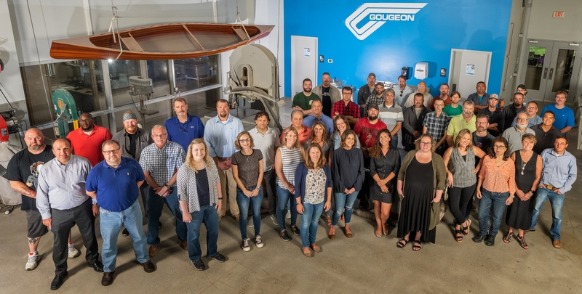
The employee-owners of Gougeon Brothers, Inc.

